Goodman & Snyder: Differential Diagnosis for Physical Therapists,
5th Edition

Appendix

APPENDIX D-8

Testicular Self-Examination

The American Cancer Society recommends following these steps every month for males starting at age 15. By conducting a monthly self-examination, each man becomes familiar with his own anatomy so that he will recognize any changes from the norm and report these to a physician as soon as possible. The self-exam is best done after a warm bath or shower; heat relaxes the scrotum, making it easier to identify anything abnormal.

- Stand in front of a mirror. Check for any swelling on the scrotal skin.
- Examine each testicle with both hands.
- Place the index and middle fingers under the testicle with the thumbs placed on top.
- Roll the testicle gently between the thumbs and fingers.
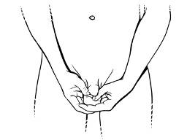
- There should not be any pain when doing the exam.
- It is common for one testicle to seem slightly larger than the other.
- Find the epididymis, a soft, tubelike structure behind the testicle that collects and carries sperm. Once you know what the epididymis feels like, you won't mistake it for a suspicious lump. Cancerous lumps usually are found on the sides of the testicle but can also show up on the front. Lumps on the epididymis are not cancerous.
- If you find a lump on your testicle, see a doctor right away. The abnormality may not be cancer; it may be an infection or hernia that requires treatment.

